Contents

Guidelines for Test Case Development using Test Manger 2

Test Case attributes 2

Test Data Maintenance 3

Sample screen 3

Change history 3

# Guidelines for Test Case Development using Test Manger

## Test Case attributes

1. **Area**

This should mention the correct area of application that test case is being written for. This will help us to identify the density of test cases for each area of the application

1. **State**

The value of attribute “State” should have the following values

|  |  |
| --- | --- |
| State | When to use it |
| Design | The test case is being designed and has not yet been reviewed and approved. |
| Ready | The test case has been reviewed and approved and is ready to be run. |
| Closed | The test case is no longer required for future iterations of this team project. |

1. **Priority**

This should have the value in descending order. 1 – Highest priority, 2- next priority so on.

1. **Test Steps**

Test steps should satisfy the following criteria

1. Mention the pre-requisite
2. Mention the steps/actions (high level) that the tester needs to perform
3. Mention the verifications that the tester needs to perform to confirm that the test case is passed/failed

## Test Data Maintenance

1. Each test case should contain references to **input test data and expected** that will be used while executing the test case
2. Test data should be maintained in a separate excel document. The document should clearly specify the values that needs to be entered/verified in various fields
3. The test case should maintain a reference to the test data by adding it to the attachments section
4. If a given test case refers to multiple screens, the test data for each screen should be maintained separately either in separate excel document or sheet

## Sample screen

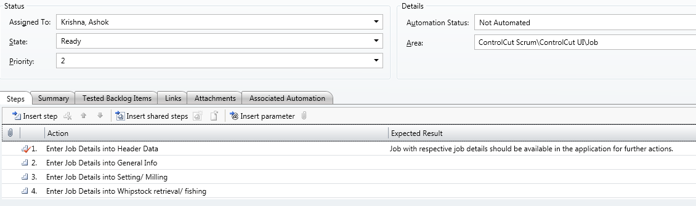

## Change history

|  |  |  |  |
| --- | --- | --- | --- |
| **Version** | **Date of Change** | **Changed by** | **Changes made** |
| 0.1 | 06-March-2012 | Deepankar Bandopadhya | Draft version |